Guitar Pedal Board – Januar 2019

# Effektgeräte

|  |  |  |
| --- | --- | --- |
|  |  | 9V Anschluss |
| Volumen Pedal |  | - |
| Wah Wah |  | 1 |
| Booster | Anfetten | 2 |
| Verzerrer | Wampler Euphoria | 3 |
| Rauschunterdrückung |  | 4 |
| Delay | Echo | 5 |
| Reverb | Hall | 6 |
| Chorus | Chor | 7 |
| Blues | Leicht verzerrt | 8 |
|  |  |  |
| Tuner | Boss Tuner | 9 |

# Unbenutzt

|  |  |  |
| --- | --- | --- |
|  |  |  |
| Blues | Verzerrer |  |
| Y-Weiche |  |  |

# Warwick Pedal Board

|  |  |  |
| --- | --- | --- |
|  |  |  |
| Pedal | RockBoard QUAD 4.1 with Flight Case 460 x 326 mm | 460 x 326 mm |
| Power | RockBoard Power Pit, Multi-Power Supply (EU)  4 x 9 V outs (500 mA total)  3 outs with adjustable Voltage  1 out with adjustable voltage | 8x 9V Anschluss |
| Power Tray | RockBoard The Tray - Universal Power Supply Mounting Solution |  |
| MOD1 Anschlüsse | RockBoard MOD 1 - All-in-one Patchbay - TRS, XLR & Barrel |  |

# Photo Setup 29.1.2019

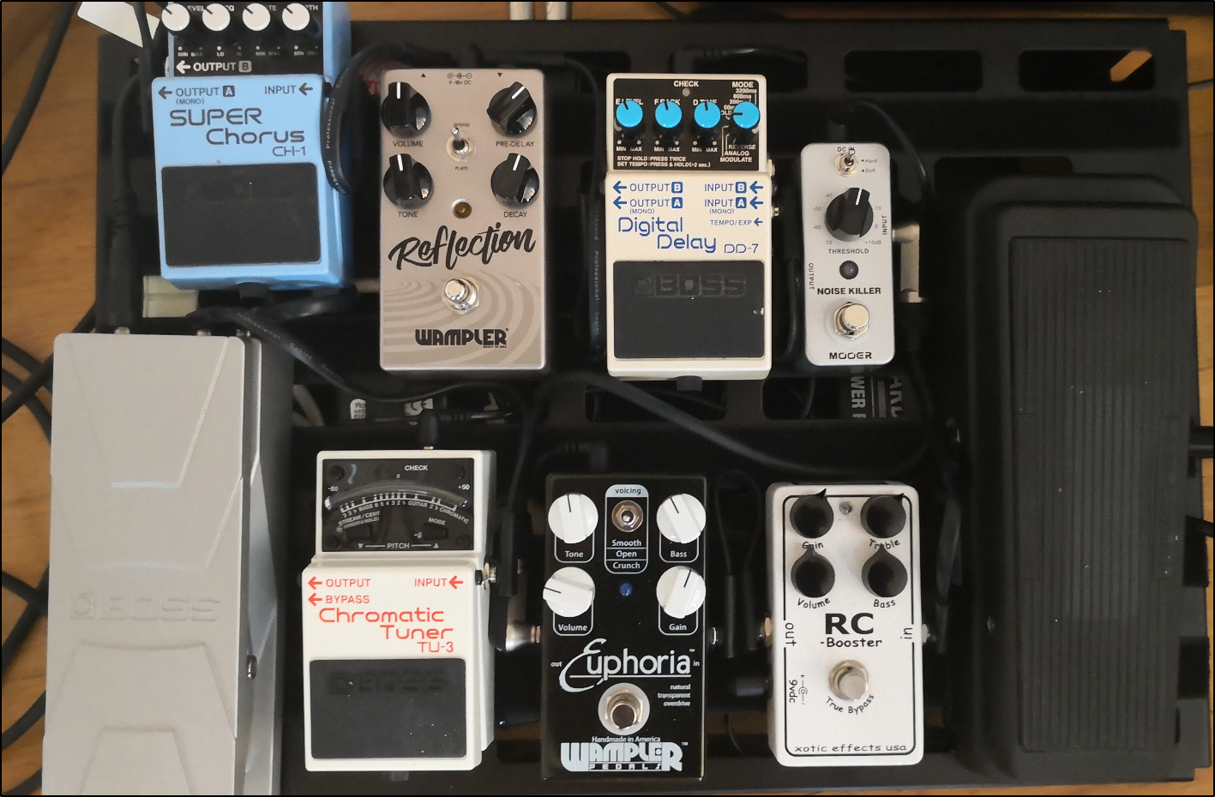

# Reihenfolge

➡ Volumen Pedal ➡ Chromatic Tuner

➡ Wah Wah

➡ RC Booster

➡ Verzerrer Euphoria

➡ Noise Killer

➡ Digital Delay

➡ Reflection (Reverb)

➡ Super Chorus